TEAM NAME: NEWBIE TIGER

School Name: Princess Chulabhorn Science High School Pathumthani, THAILAND

Team Member:

1. Mr. Waranthorn Chansawang
2. Mr. Thunchanok Watthapornsiri
3. Ms. Pimmada Sawangwong
4. Ms. Parinporn Chairattana-Apirom

Title of Invention: Food Waste Controlling Program for Restaurant (FWCR)

Objectives:

1. In order to reduce the problem of discarding raw materials, cooking in vain

2) In order to develop a solution to reduce food waste problems

Theme:

In the past, many countries have a campaign about food waste problems. Due to these problems affect humans widely. Such as the economic impact, that is having that has been dumped in large quantities shows the investment of useless resources, wasting more budgets for garbage disposal. And also affect the environment because most of the food has been destroyed by landfill, which causes Methane gas that results in a Greenhouse effect that is 25 times stronger than Carbon dioxide, etc. We see these problems need to be solved. So we have invented "Food Waste Controlling Program for Restaurant" that help to reduce food waste problems from restaurants, which is the place that people come in a large number in each day.

Originality:

Food waste crisis is one of the world’s important problems which developed countries and developing countries are facing with. In each year, 1.3 million tons of food all over the world were thrown away and being a food waste. This is about 1/3 of the food produced for human (Gustavsson et al., 2011). Even in European Union (EU), which is known as developed countries, also has such a large amount of food waste, 89 million tons per year or 180 kg per person per year in average. In the past, many countries have done many campaign to reduce the food waste problem such as charging money according to the amount of waste, donating the food, and segregating the waste. But that are the way of solving symptoms, not from the root cause. So, we are thinking of how to solve it from the root cause focusing on the situation in the restaurant. To reduce the food waste in the restaurant we create a program to calculate amount of ingredients that restaurant should buy per day. Artificial Intelligence (AI) was used in the program to collect the information such as amount of ingredients and other factors affecting the number of customers for example weathers, prices, location of the restaurant etc. Then, these factors are calculated and those numbers are used for predicting the amount of ingredients the shop should buy. In order to reduce the number of food waste from restaurants.

Description:

Our innovation is the program that helps predict the amount of ingredients used in cooking in store for reducing food waste problems in restaurants. The working of the program is, we will collect the amount of ingredients that store purchased and amount of ingredients that store used for cooking. Then, we will collect it in number form directly from restaurants. After that, we will collect data from outside which all data from external factors are all the numbers. Such as weather data from the Meteorological Department according to each day. By looking at the probability of in each situation such as rain, which may cause people less to eat outside the house, causing remains of ingredients in cooking. Next, variety in foods menu because any restaurant that has a few menus may cause people to come less. Because of boredom, the price of food because if it is expensive, people that have low to moderate incomes would not come to that restaurant. And the popularity of the restaurant, etc. Which data from external factors can be obtained from conducting surveys from consumers. By which our survey will be evaluated in number from 1-5 according to satisfaction, starting from 1 is very poor, 2 is poor, 3 is fair, 4 is good, and 5 is very good. Then bring the data to be stored as a Database and extract them to calculate and predict by Artificial Intelligence (AI) which uses Multiple Regression to process. Resulting in numbers and graphs that are quite reliable. The results will help to manage the amount of ingredients used for cooking worthy and efficiently.

Drawing:

Introduction of the program

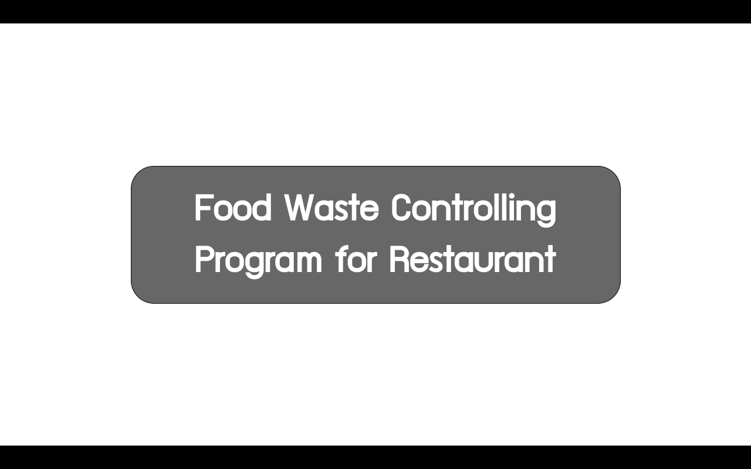



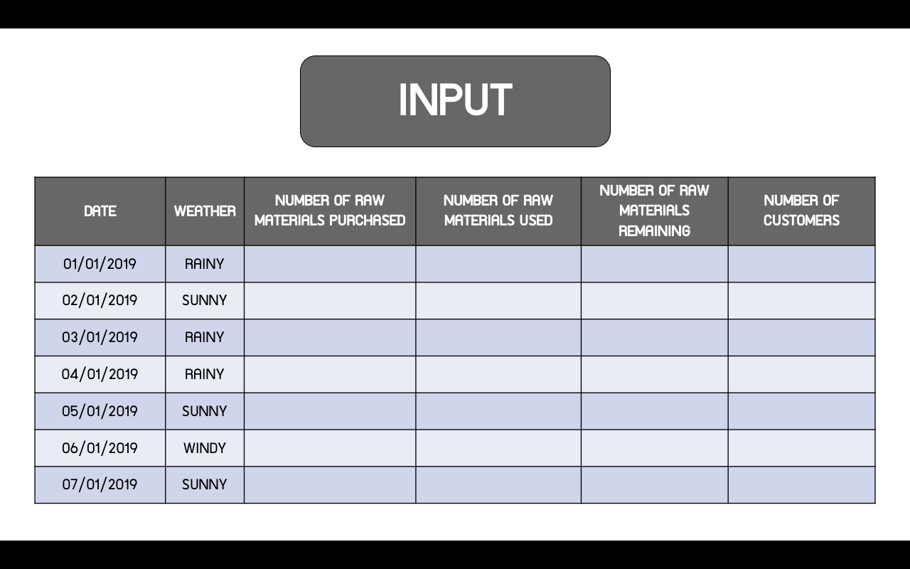



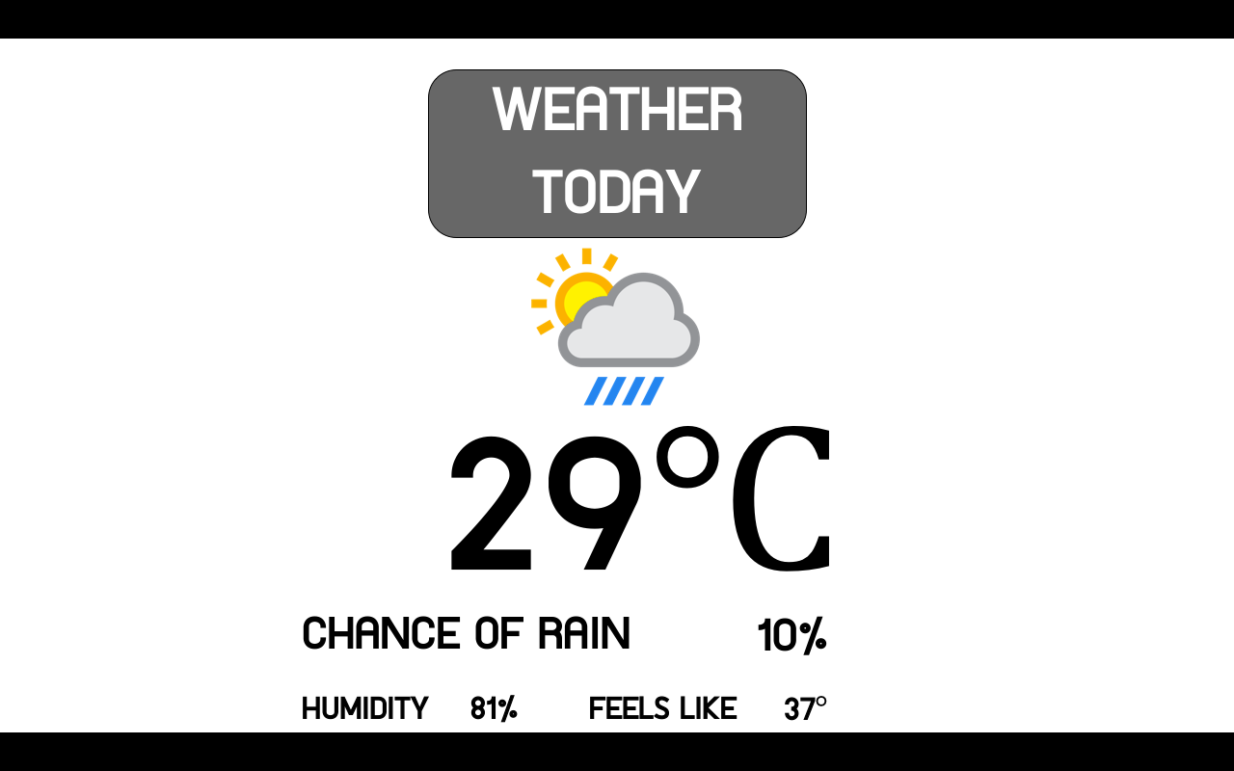

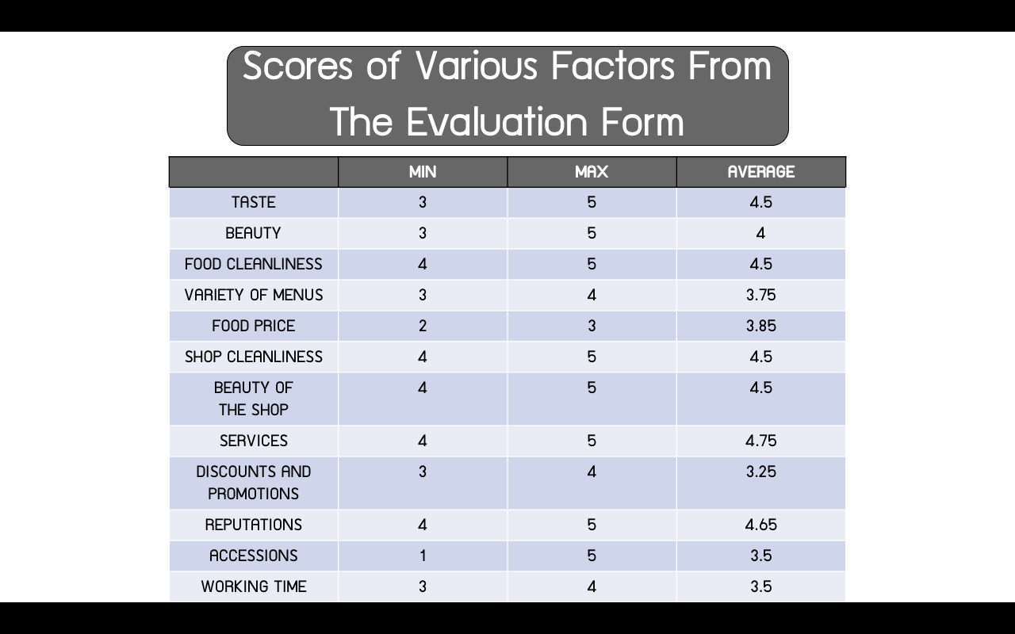





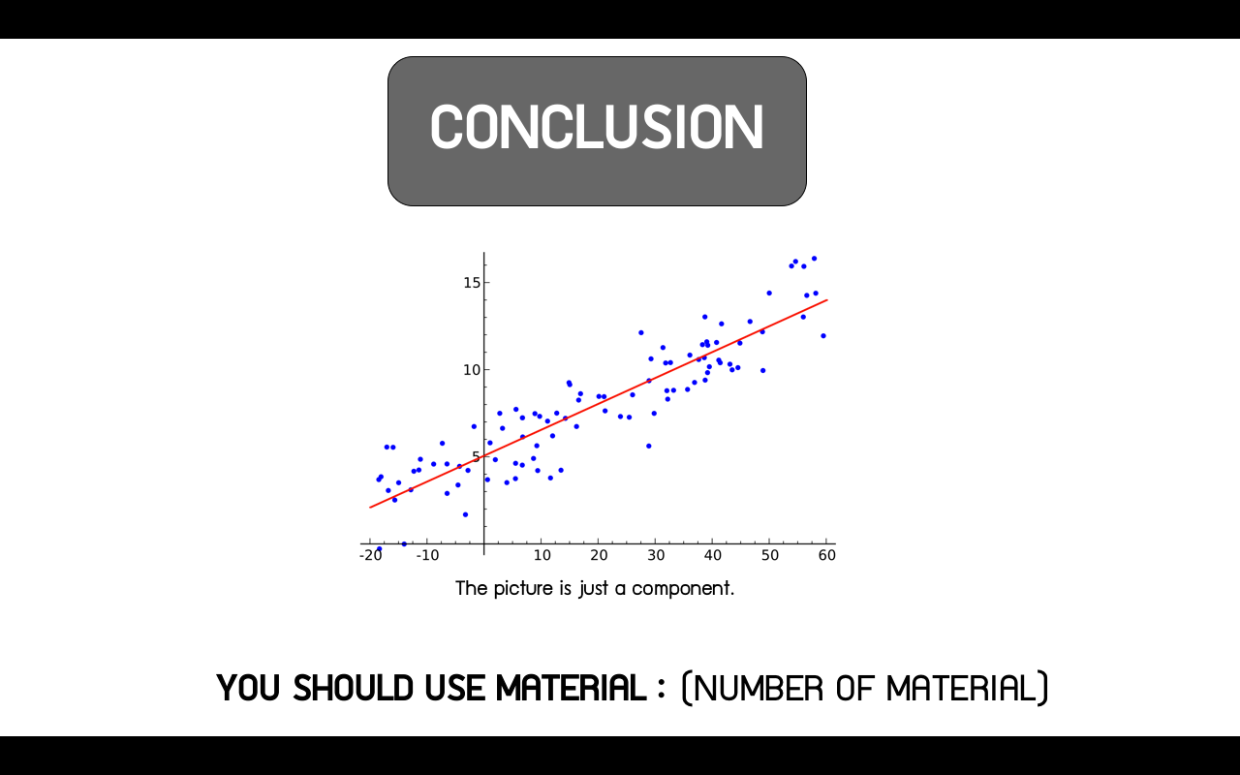

Working of the program

